**Solution2**

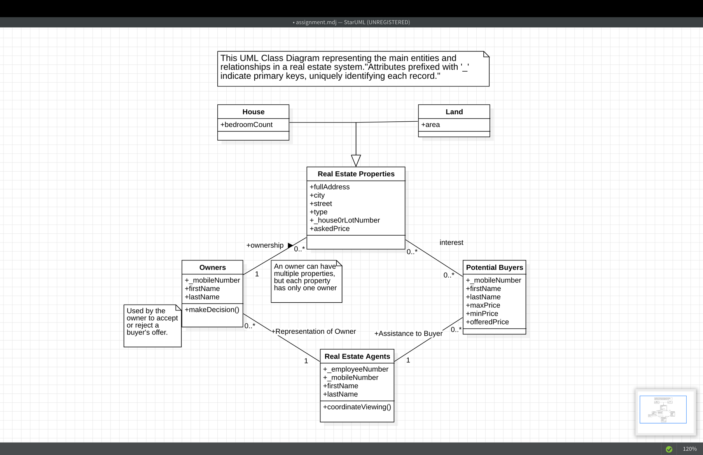

This UML diagram represents the main entities of the real estate system and their relationships. These entities include houses, land, real estate properties, owners, potential buyers, and real estate agents.

“**Attributes prefixed with '_' indicate primary keys**, uniquely identifying each record."